***A Mini Project Synopsis on***

# WORKLY- EMPLOYEE MANAGEMENT SYSTEM

**T.E. - I.T Engineering**

**Submitted By**

|  |  |
| --- | --- |
| **Lakshit Patil** | **20104043** |
| **Kritika Donde** | **20104102** |
| **Disha Panchal** | **20104126** |

**Under The Guidance Of**

## Mrs. Rujata Chaudhari



**DEPARTMENT OF INFORMATION TECHNOLOGY**

## A.P. SHAH INSTITUTE OF TECHNOLOGY

G.B. Road, Kasarvadavali, Thane (W), Mumbai-400615

UNIVERSITY OF MUMBAI

**Academic year: 2022-23**

## CERTIFICATE

This to certify that the Mini Project report on **Workly - Employee Management System** has been submitted by Lakshit Patil (20104043), Kritika Donde (20104102) and Disha Panchal (20104126) who are the students of A. P. Shah Institute of Technology, Thane, Mumbai, as a partial fulfilment of the requirement for the degree in Information Technology, during the academic year 2022-2023 in the satisfactory manner as per the curriculum laid down by University of Mumbai.

**Mrs. Rujata Chaudhari**

**Guide**

**Dr. Kiran Deshpande Dr. Uttam D. Kolekar**

**Head of Department of Information Technology Principal**

**External Examiner(s): 1.**

**2.**

**Place:** A.P Shah Institute of Technology, Thane

**Date:**

## 

## ACKNOWLEDGEMENT

This project would not have come to fruition without the invaluable help of our guide Mrs. Rujata Chaudhari. Expressing gratitude towards our HOD Dr. Kiran Deshpande, and the Department of Information Technology for providing us with the opportunity as well as the support required to pursue this project. We would also like to thank our teachers who gave us her valuable suggestions and ideas when we were in need of them. We would also like to thank our peers for their helpful suggestions.

## ABSTRACT

An Employee Management System is a distributed application that will be developed to maintain the details of employees working in any organization. It would maintain the information about the personal details of employees, so that the human resource of the organization can easily know the details of all its employees. It would be simple to understand and can be used by anyone who is not even familiar with legacy employees system. It would be user friendly and just ask the user to follow step by step operations by giving him few options. It would be fast and can perform many operations of a company. This software package would be developed using the powerful coding tools of Visual Basic at the frontend with a Microsoft Access database at backend. For further enhancement or development of the package, the user’s feedback will be considered. The Employees Management Software would make it easy for the employer to keep track of all records. The combination of these modules into one application assures the perfect platform for re-engineering and aligning Human Resource processes along with the organizational goals. This proposed system would bring about an easy way of maintaining the details of employees working within any organization. The goal of this project is to design and develop an employee management system to fill existing gaps in the electronic management of employees.

**TABLE OF CONTENTS**

1. Introduction… 6
   1. Purpose 7
   2. Problem Statement… 7
   3. Objectives. 8
   4. Scope 8
2. Literature Review… 9
3. Proposed System… 10
   1. Features and Functionality… 10
4. Requirements Analysis. 11
   1. Block Diagram (Flowchart) 12
   2. Use Cases… 13
5. Project Design. 13
   1. Use Case Diagram… 13
   2. Data Flow Diagram (DFD) 14
6. Result and Discussion 17
7. Technical Specification. 22
8. Project Scheduling… 23
9. Conclusion and Future Scope 24
10. References. 25

# Chapter No: 1

## INTRODUCTION

Employees are the backbone of any company therefore their management plays a major role in deciding the success of an organization. Human Resource Management Software makes it easy for the employer to keep track of all records. The ever changing trend in technology brought the necessity for the automation of everything from paper-and-pen based to absolute computer domination. The overwhelming emergence of computers paved way to easier access of information that leads to increased production, efficiency and reliability.

Large and even small and medium sized companies have always implemented a system (whether electronically or manually) to be able to manage its employees effectively. The effective management of these records ensures sound decisions based on full, accurate and up-to-date information to be made. This also ensures that any decision made can be traced, scrutinized and justified if necessary. The Human Resource segment have long used such information to track employees’ performance, incentives, problems etc. to streamline the company’s input and consequently, maximize its productivity.

This need paved the way to the development of databases to store and retrieve important information. In the development of generic management systems, the organization of storage of data was prioritized. A typical database management system controls the creation, maintenance and use of the database storage structures of institutions.

6

# Purpose:

# The software is created to improve Employee-admin relationships.It will help the employees to monitor work, undertake effective communication, teamwork coordination, and better decision-making through well-informed information.For this project we will try to overcome as many as problems.

# Problem Definition:

**Problems Identified:**

The companies can use a complete Employee Management app solution for enterprise, including Employee and

HR application and admin panel. The mobile and web-based app help companies to automate the entire process

of employees’ payroll, productivity management, attendance & time data through performance management

and attendance& time management modules. With a productive workforce and environment, the companies

cut wasting-time, improve communication, boost engagement, and raise contentment levels across the

organization, resulting in higher profits and decreasing overall costs.

**Solution Purposed:**

An employee management system provides managers with insights into their workforce, and helps them to better

plan and manage work hours to easily control labor costs and increase productivity.

.

**OBJECTIVES**

* To develop a well-designed database to store employee information.
* To make existing system paperless and save lots of bunching logs of files on the shelf which makes the

later on access of the record not at all easy task and overhead to peoples.

* Making the existing system fully automatic which will save lots of human resources work. As the

current system is all human resource work is needed to maintain and keep the record and details of

every employee under and organization to keep track of every employee in staff working in an

organization.

* To create a user friendly front-end for the user to interact with the system, to be able to sort employee queries by department and have a quick reach for all the data.
* To also be able to remove details of employees that are no longer a part of the organization.

**SCOPE**

* User can login to their account for accessing their data.
* User friendly interaction between user and system.
* Can help in maintaining the employees records.
* Can focus on each employees attendance and the number of leaves.
* Possibilities of checking salary at anytime.
* Can also provide better Employee-Manager Relationship.

## Chapter No : 2

## Literature Review

1. Kellerman, 2007( Pg 17) & McGowan (2010) published a paper that stated:

Darker forces sometimes drive leaders as well as their followers. Bad leadership is as ubiquitous as it is insidious Kellerman (2007) further points out that, “like good leaders, bad leaders are characterized by traits such as intelligence, high energy, strong drive for power and achievement, decisiveness, and determination. Bad leaders have a skill set that ranges from being good at communicating to being good decision making. Kellerman (2007) also describes bad leaders as, “incompetent, rigid, intemperate, callous, corrupt, insular, and evil” (Kellerman, 2007, Pg. 17). McGowan (2010) also notes, “Leadership can’t lead if it can’t see” (McGowan, 2010, Pg. 3).

Employees not only need guidance from their managers or leaders, but they also need to know that they will be there to help them when they need them or to help put things back on the right track. Leadership need not imply that a leader is, by nature, wise, and inspirational.

1. Similarly Lazenby & Kauffman published in 2008 pointed out:

“As Kauffman (1987) points out, “aging, in itself, does not lead to mental impairment, such as memory loss or a breakdown in intellect. They [older workers] may no longer be striving for top pay; they may see the need for better balance between work life and home life; their children may be self-supporting and their monetary needs are no longer a driving force” (Kauffman, 1987, Pg. 43).

Some employees might be motivated by monetary rewards, managers also need to be aware that motivation could also depend on the age of the employee. Although one might not think that age is a factor when it comes to motivating workers . Younger employees tend to be more motivated by monetary rewards and older employees are generally motivated by other factors. Not motivating employees can then lead to inter- departmental or departmental conflict – especially if employees believe inequality exists.

# Chapter No: 3

# Proposed System

## FEATURES AND FUNCTIONALITY:

* + Feature 1: Time and Attendance Management:

Time and [attendance management](https://desktrack.timentask.com/blog/attendance-management-software/) is the best way to manage the team’s activity records. The software monitors employee working hours and manages attendance data which helps [improve workforce productivity](https://desktrack.timentask.com/blog/how-to-encourage-employees-to-improve-their-working-efficiency/) and employee engagement and helps in reducing HR administration workload and payroll issues.

* + Feature 2: Leave Management:

The employee can apply for leaves effortlessly via the system while the admin can manage these leaves. Admin has the options for leaves like accept, reject or keeping it pending.

* + Feature 3: Salary Management:

The users can view their salary status anytime. The software shows the status of salary for each employee under their account.

# Chapter No: 4

## REQUIREMENT ANALYSIS

**Functional Requirements:**

* + - The system provides function of login as admin or as Employee.
    - Once you are logged in as an admin you will have various options like Employee management, leave management, salary management etc.
    - There is also an option to add departments and view reports via admin module.
    - If you are logged in as user there are options for applying for a leave as well as viewing leave status.
    - The user can also view salary status and other profile details.

**Non-Functional Requirements:**

* + - Availability: The system is available to all its users be it admin or any employee all the time i.e. 24x7.
    - Maintainability: The system is very user friendly and flexible. Hence it is very easy to add new features according to future requirements.
    - Scalability: The system is capable of handling all employees and they can all use it at the same time.

**FLOWCHART:**

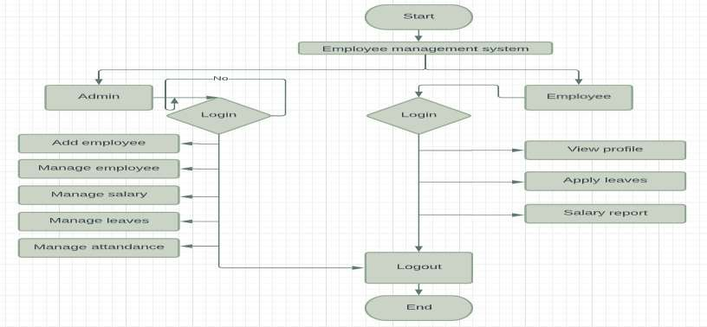

**Figure 1: Flowchart**

## Chapter No: 5

**PROJECT DESIGN**

## Use Case Diagram:

WORKLY: Employee Management System

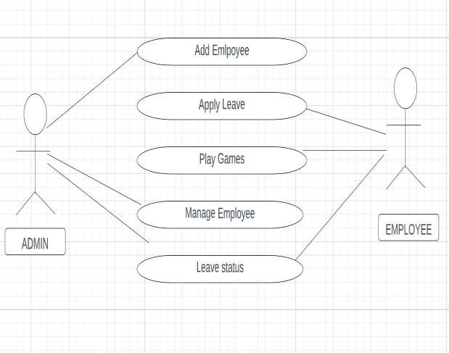

## Figure 2: Use Case Diagram

**DFD (Data Flow Diagram) Diagram:**

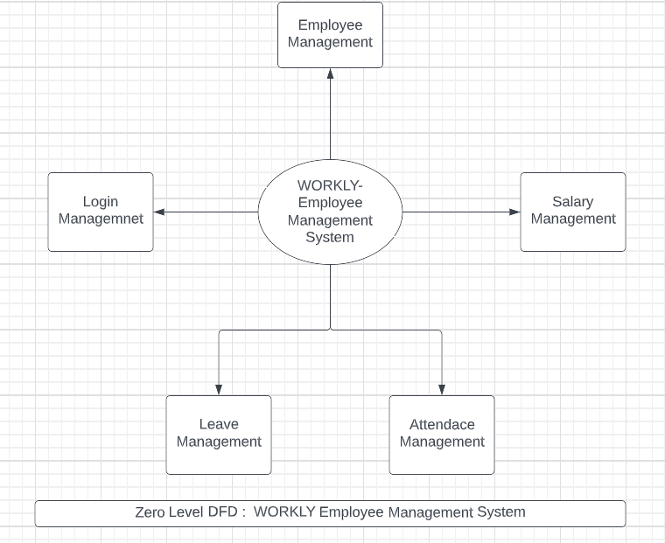

**Figure 3: DFD (Level 0)**

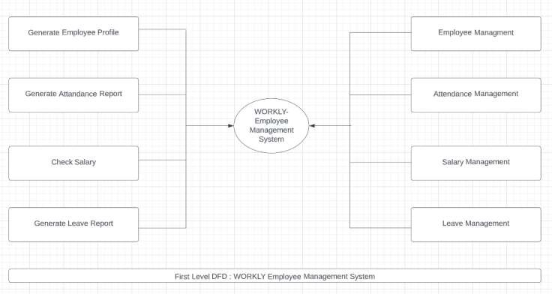

**Figure 4: DFD (Level 1)**

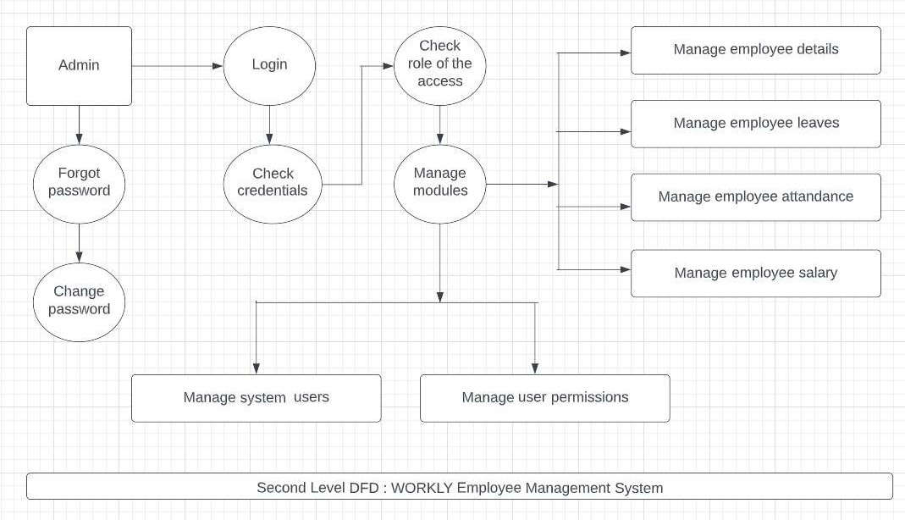

**Figure 5: DFD (Level 2)**

16

## Chapter no 6:

## RESULT AND DISCUSSION

## Home page:

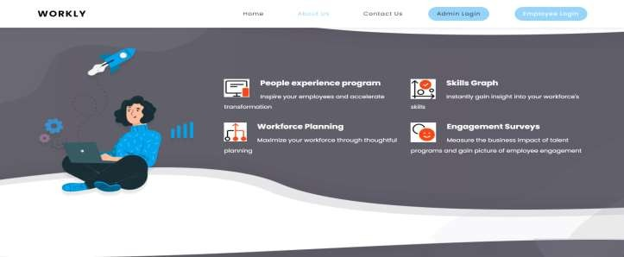

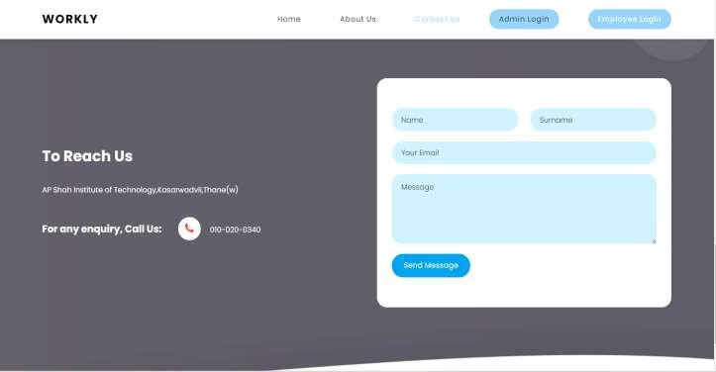

18

**Admin login:**

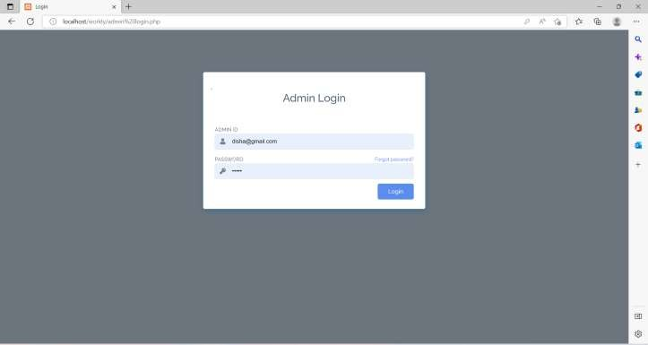

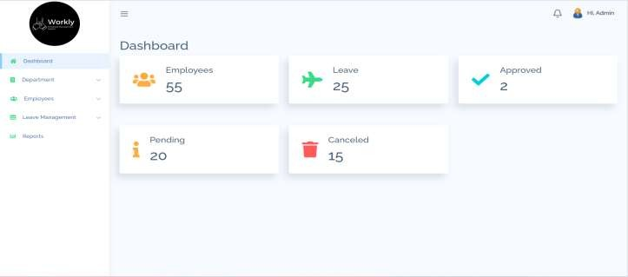 **Admin Dashboard:**

19

**Employee Login:**

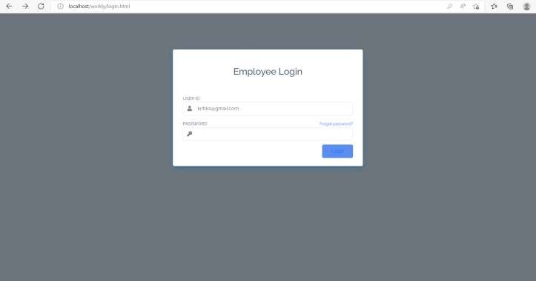

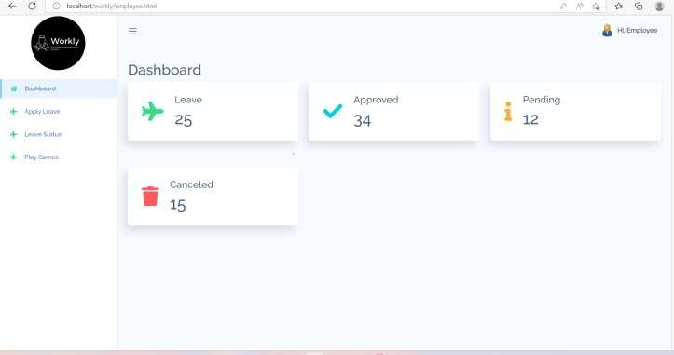 **Employee Dashboard:**

20

**Gantt Chart:**

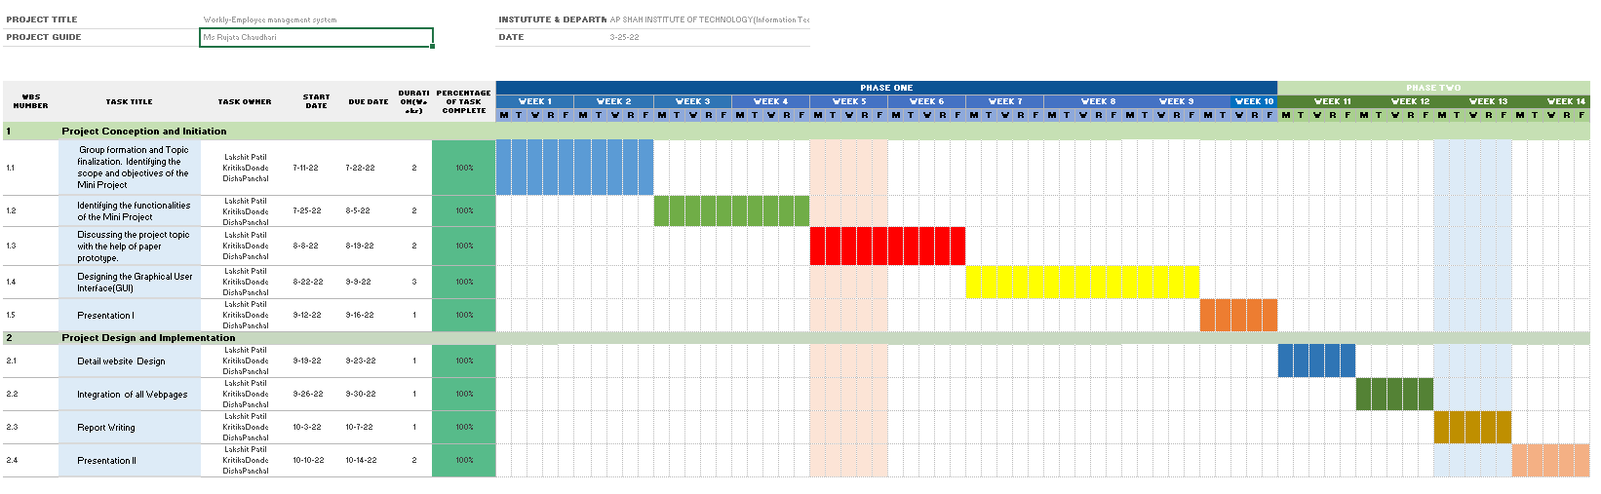

**Chapter no 7 :**

**TECHNICAL SPECIFICATIONS**

## Development: Sublime

Sublime text editor is a source code editor made by Microsoft for Windows, Linux, MacOS. It has various features such as Debugging, Syntax highlighting, extension, intelligent code completion.

## Frontend: Html, CSS.

As a web developer, the three main languages we use to build websites are HTML and CSS. We use HTML to structure the site, and we use CSS to design and layout the web page. These days, CSS has become more than just a design language, though. You can actually implement animations and smooth transitions with just CSS.

## Backend: MySQL

MySQL is the most popular database system used with PHP. PHP combined with MySQL are cross-platform (you can develop in Windows and serve on a Unix platform). The data in a MySQL database are stored in tables. A table is a collection of related data, and it consists of columns and rows. Databases are useful for storing information categorically.

# Chapter No: 8

**PROJECT SCHEDULING**

|  |  |  |  |
| --- | --- | --- | --- |
| **Sr. No** | **Group Member** | **Time duration** | **Work to be done** |
| **1** | Lakshi Patil Kritika Donde Disha Panchal | 2st week of July | Implementing 1st module/ functionality (designing of the login and registration pages) |
| 3nd week of July | Testing 1st module  (*linking the login and registration pages,creating home page* ) |
| **2** | Lakshi Patil Kritika Donde Disha Panchal | 1st week of September | Implementing 2nd module/ functionality  (*creating admin and user modules and implementing them*) |
| **3** | Lakshi Patil Kritika Donde Disha Panchal | By the end of September month | Implementing 3rd module/ functionality  (*Connecting all the pages and backend connectivity*) |

23

# Chapter 9:

## CONCLUSION AND FUTURE SCOPE

To conclude, WORKLY works as a system which can access all the available facilities and performs various functions.The project has a very vast scope in future. It can be implemented in various fields in future.It can also be updated in the future as and when requirement for the same arises, as it is very flexible.

# Chapter 10:

## REFERENCES

1. – Begg Carolyn, Connolly Thomas, Database systems (a Practical approach to Design, Implementation, and Management), Addison-Wesley, an imprint of Pearson Education,

University of Paisley (U.K.), Fourth edition 2005

1. – Bodnar George /Duquesne University/, Hopwood William /Florida Atlantic University/, Accounting Information systems, Eighth Edition, Prentice Hall, Upper Saddle River, New Jersey .
2. – Andersen Virginia, Access 2000: The Complete Reference, Blacklick, OH, USA: McGraw-Hill Professional Book Group, 2001, <http://site.ebrary.com/lib/vaxjo/Doc?id=5002842> (2006-05-25).
3. – Andersson Tobias, [DAB744] C# Course Lectures, School of Mathematics and System Engineering, Växjö University.
4. - http://msdn.microsoft.com/library/default.asp?url=/library/en- us/vbcon/html/vboritextboxctltasks.asp (2006-05-25)